IoT commands for mosquitto_broker:
Output:
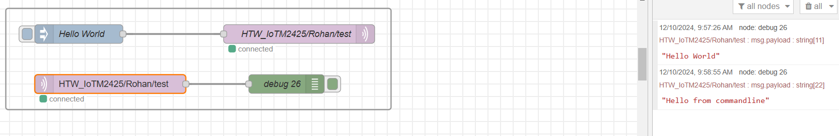

Checks if Node-Red is Enabled or Disabled:
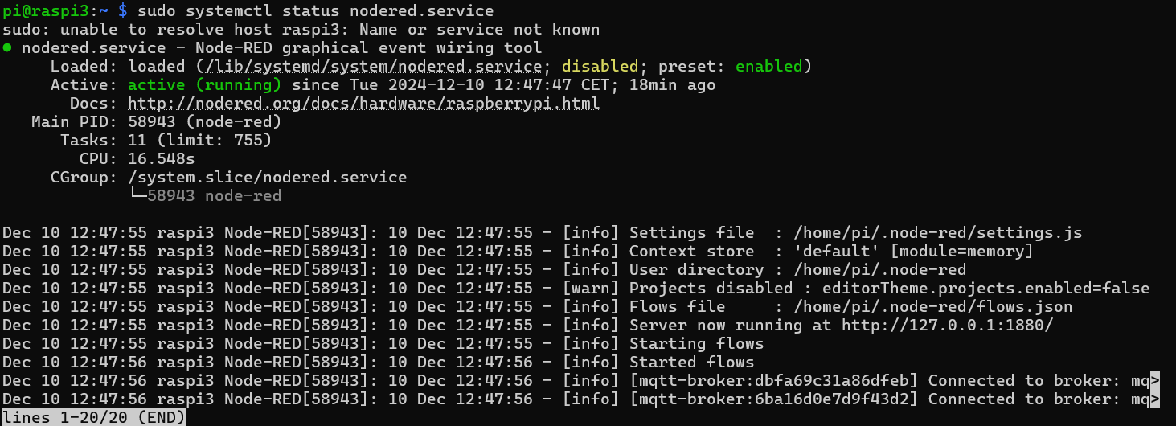
sudo systemctl status nodered.service To know the status of service and here in this case it’s node-red
sudo systemctl enable status nodered.service To enable the node-red
sudo systemctl restart nodered.service To restart node-red
To allow anonymous listerners first use this command and do the following
coment out:
`#include_dir /etc/mosquitto/conf.d`
add the following lines:
```
allow_anonymous true
listener 1883
```
Mosquitto service restart:

<code>sudo systemctl restart mosquitto</code>
Start Mosquitto service at boot:
<code>sudo systemctl enable mosquitto</code>

